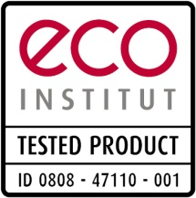
eco-INSTITUT-Label

Declaration of Conformity

Transfer to identically manufactured

product with deviating product designation

Certificate Holder (Certificate of Origin) |  | Examination Institute
 |  | eco-INSTITUT Germany GmbH
 |  | Schanzenstr. 6-20
 |  | 51063 Cologne

Product description:
of tested product |  | of identically manufactured product

Distributor of identically manufactured product:

Specification about certification document of tested product:
Certification No.: | - -
Validity of certification document:

Identical substances of both products: | Yes  No | Identical production process of both products: | Yes  No

Herby the ordering party certifies that the data specified above were truthfully provided.
,
Place, date |  | Signature (Certificate Holder)
,
Place, date |  | Signature (Distributor)

